Dummy link --🡪 <https://chaitukumar15.github.io/todolist/>

**Todo list**

Core Functional Requirements

1. Add Tasks
   * Users should be able to add new tasks with a description.
   * Input should be validated to ensure it is not empty.
2. View Tasks
   * Users should be able to view a list of all tasks.
   * Each task should display its description and have options for editing and deleting.
3. Edit Tasks
   * Users should be able to edit the description of an existing task.
   * Changes should be saved and updated both in the UI and in storage.
4. Delete Tasks
   * Users should be able to remove tasks from the list.
   * The task should be removed from both the UI and storage.

This is the 1 st screen you need to create

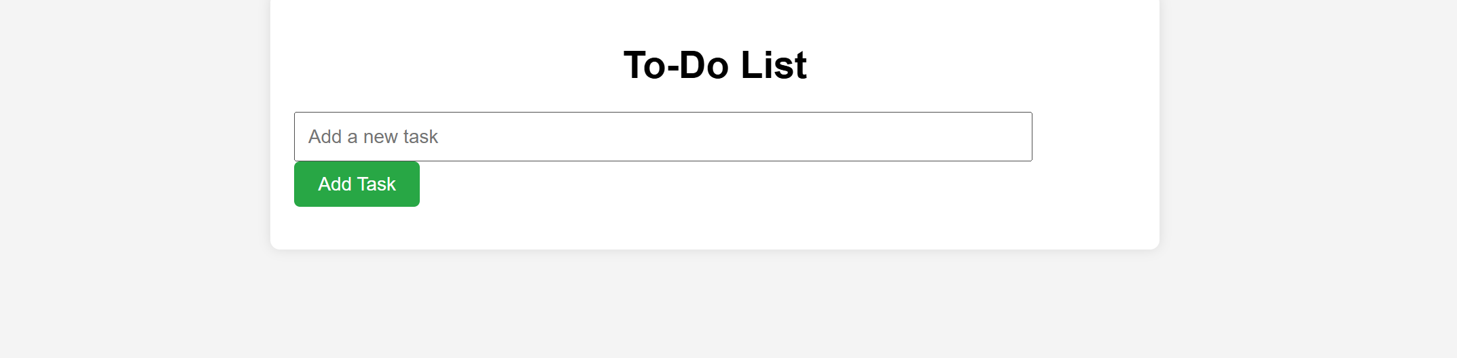

Here we need to take the input from form and display in the task

As given in the below screen

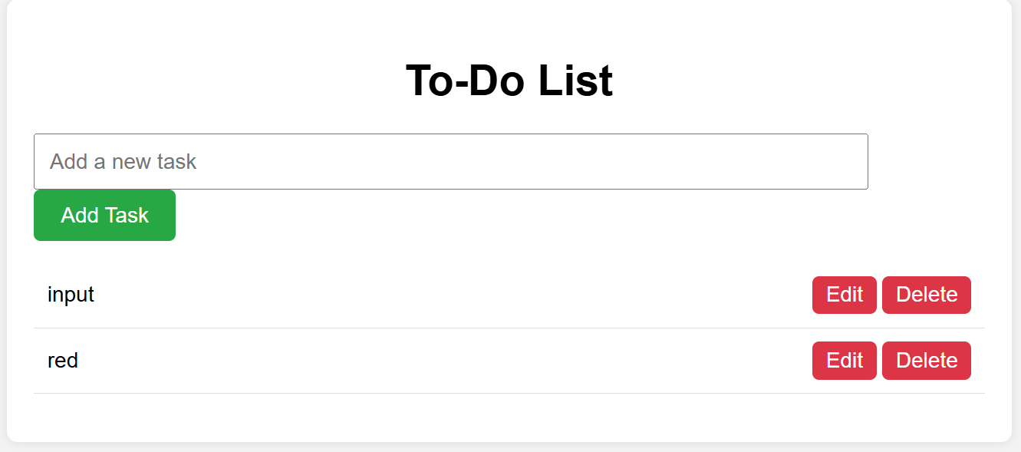

If you press delete button you need to delete the task like

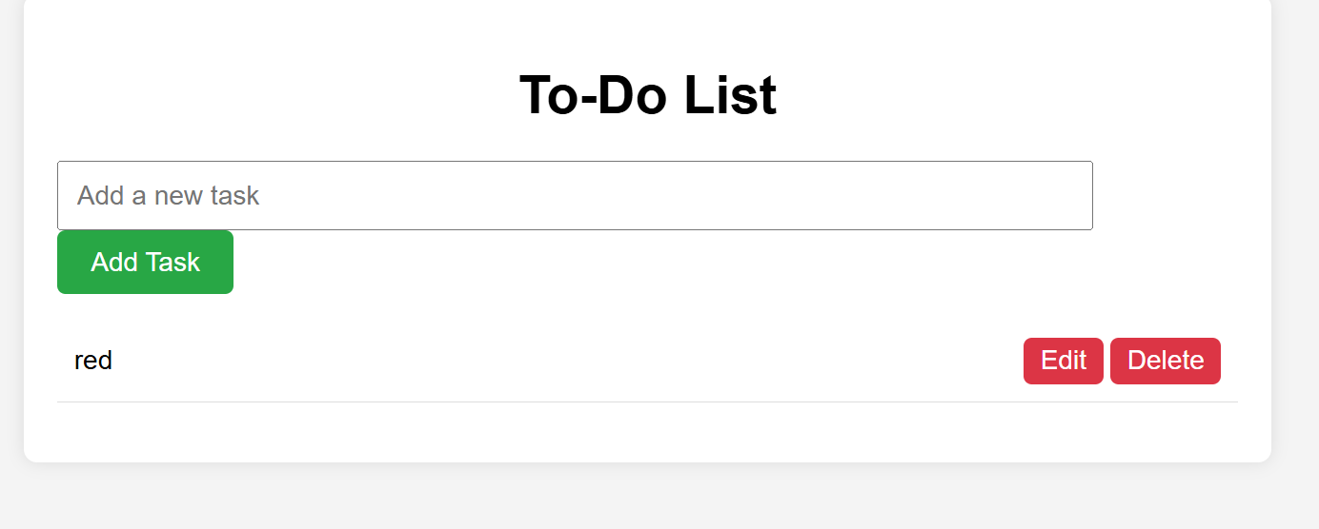

You need to edit the task by adding alert ;

As shown below

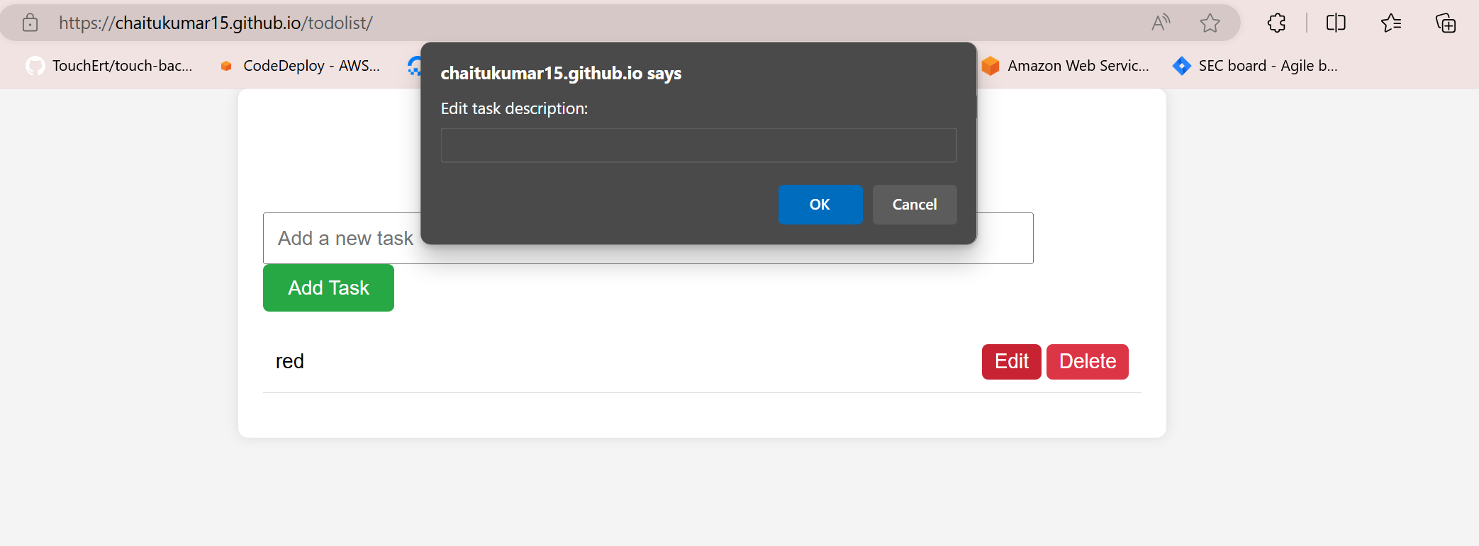

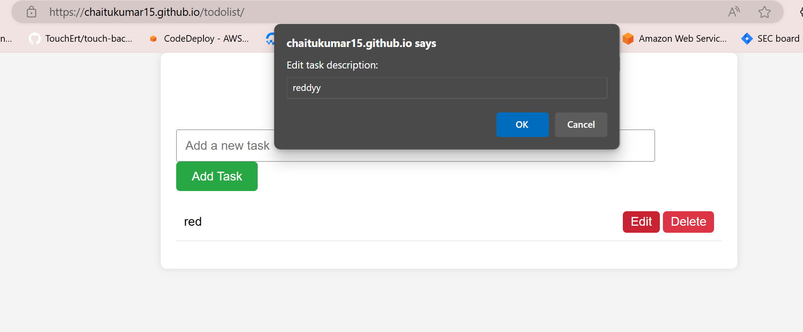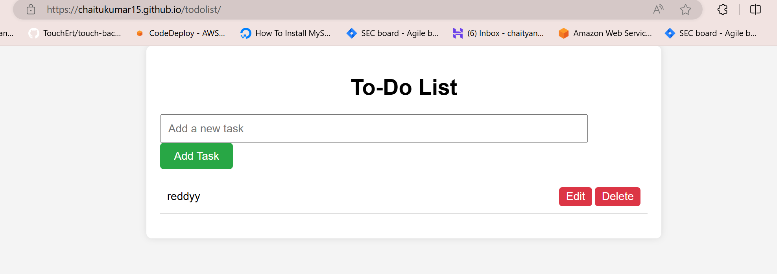

<https://chaitukumar15.github.io/todolist/>

check this link for reference